- 1 LoRaWAN® overview
  - 1.1 what is LoRaWAN®
  - 1.2 LoRaWAN® network architecture
  - 1.2.1 LoRaWAN® end device
  - 1.2.2 LoRaWAN® Gateway
  - 1.2.3 LoRaWAN® network server
  - 1.2.4 LoRaWAN® application server

LoRaWAN® overview

1.1. what is LoRaWAN®↑
LoRa Alliance® [1], is a nonprofit association that defines and promotes the LoRaWAN® .
This section provides a general overview of LoRaWAN®. It particularly focuses on the LoRaWAN® end device. LoRaWAN® is a type of wireless telecommunication network designed to allow long-range communication (kilometers) at a very-low bit rate. Hence, it is suitable for transmitting small-size payloads such as sensor data. Moreover, it enables long-life battery-operated sensors and actuators (they can last up to 10 years on a single coin cell battery).
Typical use cases are for examples smart farms to measure soil moisture in rural areas. However, thanks to the deep indoor penetration, for example, to cover easily multifloor buildings. It is used also for indoor application or for water-meter counters in cities. It can be deployed both on public and private networks since it operates on license-free subgigahertz bands. Moreover, it allows saving operator fees.
LoRaWAN® is a MAC (media access control) layer protocol built on top of LoRa® modulation.
LoRa® (which stands for "Lo(ng) Ra(nge)") is a proprietary (Semtech) low-power wide-area network (LPWAN) modulation technology. It is based on spread-spectrum modulation techniques that are similar to and a derivative of chirp spread spectrum (CSS) modulation.
LoRa® operates on the following license-free subgigahertz bands:
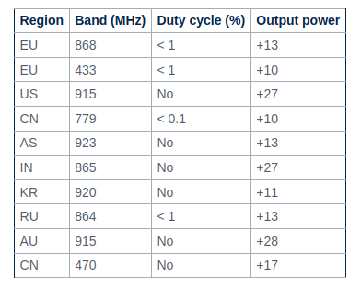

While the physical layer of LoRa® is proprietary, the rest of the protocol stack (LoRaWAN® ) is kept open and its development is carried out by the LoRa Alliance® .
LoRaWAN® is a protocol layer that defines how devices use the LoRa® radio. It defines the network architecture, the communication, and security protocol and ensures interoperability with the LoRaWAN® network.
LoRaWAN® message types are used to transport both MAC commands and application data. They can be uplink and downlink. Message types depend on the specification’s versions 1.0.x and 1.1. The authenticity and integrity of messages between the end device and the network server uses AES-CMAC (cipher-based message authentication code). It is also called MIC (message integrity code). The secure communication between the end device and the application server uses AES-128 encryption.
The LoRa Alliance® develops and maintains the LoRaWAN® protocol.
As announced by the LoRa Alliance® on December 7, 2021, LoRaWAN® is officially approved as a standard for LPWAN (low power-wide area networking) by the International Telecommunication Union (ITU). The LoRa Alliance® certification program[2] certifies end devices. It provides end users with confidence on the devices reliability and compliancy with the LoRaWAN® specification.

1.2. LoRaWAN® network architecture↑
The LoRaWAN® network is structured in a star of stars topology where end devices are connected via a single LoRaWAN® link to one gateway.
The overall architecture is mainly composed by the following elements:
- End devices are wirelessly connected to a LoRaWAN® network through radio gateways.
- Gateways forward all received LoRaWAN® radio packets to the network server.
- Network server is the center of the star topology. It runs on a server that manages the entire system.
- Application servers handle all the application layer payloads of the associated end-devices and provides the application-level service to the end user.
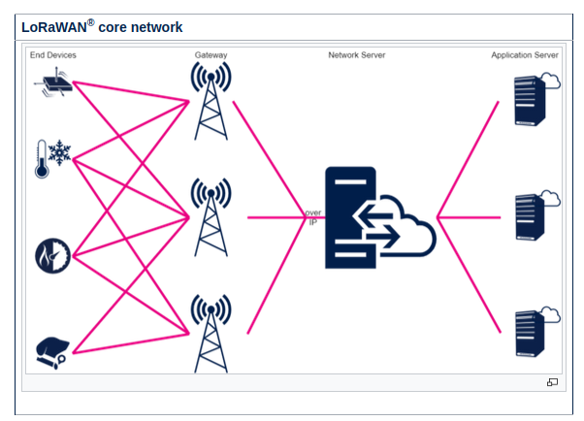
LoRaWAN® networks primarily use the ALOHA method for communication between end devices and their associated network servers.
End devices send data through one or more gateways to the network server.
In a LoRaWAN® network, packets broadcast asynchronously by end-devices are picked up by one or more gateways within the network.
There are several network server (NS) providers (private and public). However, gateways are only registered to a specific NS. Hence, end devices should be registered only to one NS. As already mentioned, the message that is sent by the end device is always received by all gateways in the range of the signal. Each gateway forwards the message to the network server that is associated to that gateway. If the end device is not registered on that NS, the NS discharges the message. If the NS receives the same message from different gateways (registered on that NS), it handles the multiple copies keeping the best. On the downlink side, the NS chooses the best gateway to communicate with a given end device. All end devices in the range (with opened Rx windows) receive that message but only the targeted end device (or end devices in the multicast use case) decodes it.
The application layers of end devices are typically connected (via the network server). There are connected to one or more application servers in the cloud (such as, dashboard, logger, proprietary protocol solution as FUOTA). The end device, exchanges messages on different ports to "the cloud". Each port is redirected to the specific application server defined into the NS.

